**Step 1: Drawing Basic Shapes With Python Turtle**

1. Create an new Repl by selecting the **“Python with Turtle”** language / environment.

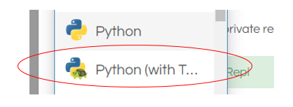

1. Begin all of your turtle programs with the following code to create a “pen”:

import turtle

myPen = turtle.Turtle()

1. Review the following chart for a list of Turtle commands.

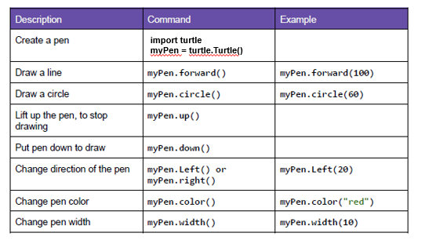

1. Use the following program to draw a red square.

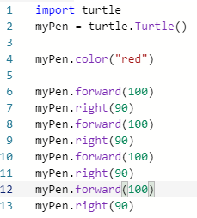

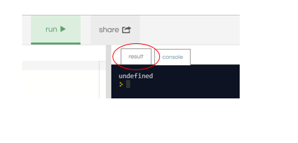

1. Switch to the “Result” window to see the square.
2. Create a program to draw any one of the shapes “b”, ”d”, or “e” shown in the figures below.   
   Provide a listing of your program code.
3. Create a program to draw any one of the shapes “c”, or “f” shown in the figures below.   
   Provide a listing of your program code.

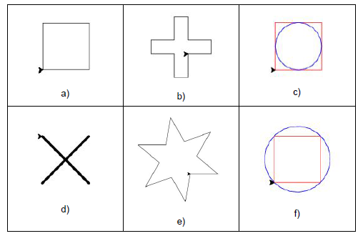

**Step 2: Christmas / Winter Theme Card**

1. Use your creativity to create a card design using Turtle.
   1. The design must have multiple figures.
   2. The design must have at least two different patterns.
   3. You may repeat patterns.
   4. Provide a listing of your program code.
   5. Provide an image of your program result.

# Bottom square part of tree

import turtle

myPen = turtle.Turtle()

myPen.color("brown")

myPen.forward(100)

myPen.right(90)

myPen.forward(90)

myPen.right(90)

myPen.forward(100)

myPen.right(90)

myPen.forward(100)

myPen.right(90)

myPen.forward(100)

myPen.right(90)

myPen.forward(100)

myPen.right(90)

myPen.forward(100)

myPen.right(90)

# Tree Program

wn = turtle.Screen()

bird = turtle.Turtle()

bird.speed(5)

bird.pensize(4)

bird.color("dark green")

bird.setpos(-50, 0)

bird.fillcolor("dark green")

bird.begin_fill()

for i in [0, 1, 2]:

bird.forward(175)

bird.left(120)

bird.end_fill()

bird.forward(25)

bird.right(90)

# create a list of colours

snow_colors = ["white", "blue", "silver"]

# make a function to draw the circles

def draw_circle(turtle, color, size, x, y):

turtle.penup()

turtle.color(color)

turtle.fillcolor(color)

turtle.goto(x,y)

turtle.pendown()

turtle.begin_fill()

turtle.circle(size)

turtle.end_fill()

def write_message(turtle, color, x, y):

turtle.penup()

turtle.goto(x,y)

turtle.pendown()

turtle.pensize(8)

turtle.color(color)

turtle.write("Merry and Joy!!", None, None, "16pt bold")

